**Use Case “Place Order”**

1. **Use case code**

UC001

1. **Brief Description**

In the AIMS Project, UC “Place Order” describes the interaction between customers and AIMS software when the customer wishes to place order. A basic flow of the events for UC “Place Order” as follows.

1. **Actors**
   1. **Name of Actor 1: Customer**
2. **Preconditions**

**There is an active network connection to the Internet.**

1. **Basic Flow of Events**
2. The customer request to place order in the view cart screen
3. The AIMS software checks the availability of products in the cart
4. The AIMS software displays the form of delivery information
5. The customer enters and submits delivery information
6. The AIMS software check the validity of delivery information
7. The AIMS software calculates shipping fees
8. The AIMS software displays the invoice
9. The customer confirms to place order
10. The AIMS software calls UC “Pay order”
11. The AIMS software save order
12. The AIMS software makes the cart empty
13. The AIMS software displays the successful order notification.
14. **Alternative flows**

Table 1-Alternative flows of events for UC Place order

|  |  |  |  |  |
| --- | --- | --- | --- | --- |
| **No** | **Location** | **Condition** | **Action** | **Resume location** |
|  | At Error!  Reference  source not  found. | If there is media of which  quantity in the stock is less  than the ordered quantity | * The AIMS software asks customer to update the cart. * The customer updates the cart. | Resumes  at Step 2 |
|  | At Step 5 | If a mandatory field is left  bank | * The AIMS software asks the customer to fill all the mandatory   blank. | Resumes at Step 3 |
|  | At Step 5 | If the phone number is  invalid | * The AIMS software asks the customer to enter a valid phone number. | Resumes at Step 3 |

1. **Activity diagrams**

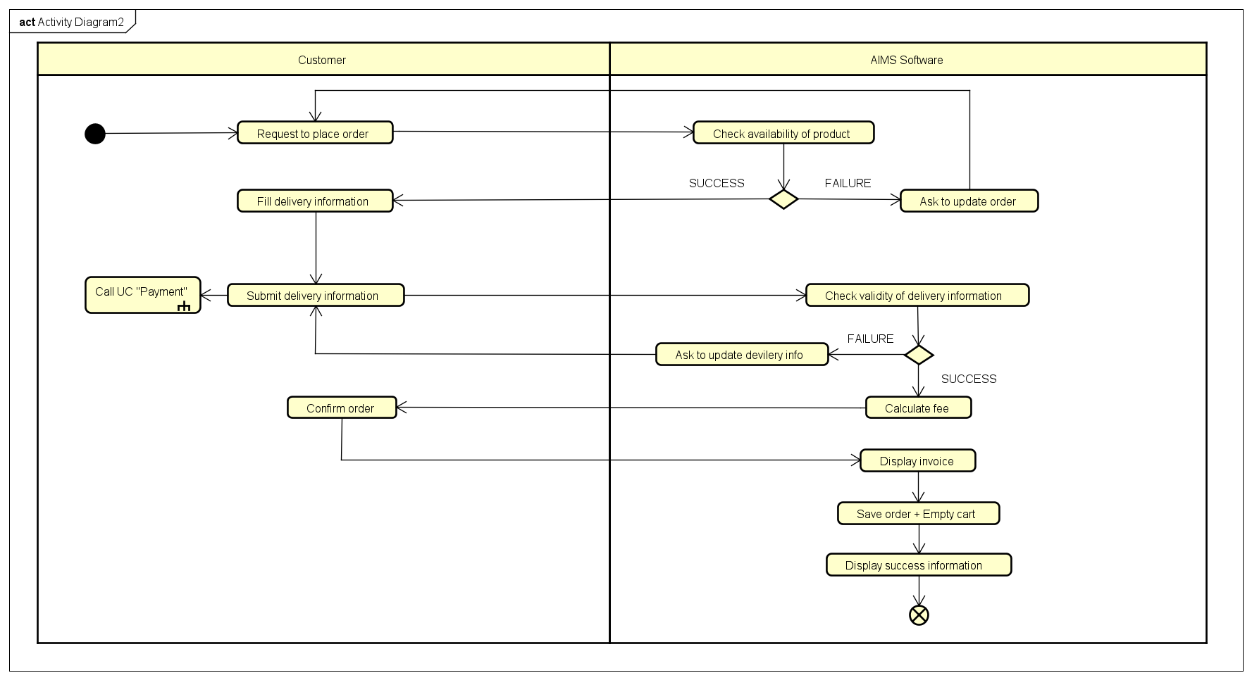

1. **Input data**

Table 2-Input data of delivery information

|  |  |  |  |  |  |
| --- | --- | --- | --- | --- | --- |
| **No** | **Data fields** | **Description** | **Mandatory** | **Valid condition** | **Example** |
|  | Receiver Name |  | Yes |  | Dao Duc Manh |
|  | Phone Number |  | Yes |  | 0913060752 |
|  | Province | Choose from list | Yes |  | Ha Noi |
|  | Address |  | Yes |  | 396 Truong Dinh Street, Hoang Mai, Ha Noi |
|  | Shipping instructions |  | No |  |  |

1. **Output data**

Table 3-Output data of displaying invoivce

|  |  |  |  |  |
| --- | --- | --- | --- | --- |
| **No** | **Data fields** | **Description** | **Display format** | **Example** |
|  | Title | Title of a media product |  | DVD Phim Vượt  ngục |
|  | Price | Price of the corresponding media product | * Comma for thousands separator * Positive integer * Right alignment | 123,000 |
|  | Quantity | Quantity of the corresponding media | * Positive integer * Right alignment | 2 |
|  | Amount | Total money of the corresponding media | * Comma for thousands separator * Positive integer * Right alignment | 246,000 |
|  | Subtotal  Before VAT | Total price of products in the cart before VAT | * Comma for thousands separator * Positive integer * Right alignment | 2,106,000 |
|  | Subtotal | Total price of products in the cart with VAT | 2,316,600 |
|  | Shipping fees |  | 30,000 |
|  | Total | Sum of subtotal and shipping fees | 2,346,600 |
|  | Currency |  |  | VND |
|  | Name |  |  | Dao Duc Manh |
|  | Phone  number |  |  | 0913060752 |
|  | Province | Choose from a list |  | Ha Noi |
|  | Address |  |  | 396 Truong Dinh Street, Hoang Mai, Ha Noi |
|  | Shipping  instructions |  |  |  |

Table 4-Output data of displaying cart

|  |  |  |  |  |
| --- | --- | --- | --- | --- |
| **No** | **Data fields** | **Description** | **Display format** | **Example** |
| 1 | Title | Title of a media product |  | CD Em về tinh khôi – Hà Trần |
| 2 | Price | Price of the corresponding media product | * Comma for thousands separator * Positive integer * Right alignment | 120,000 |
| 3 | Quantity | Quantity of the corresponding media | * Positive integer * Right alignment | 2 |
| 4 | Amount | Total money of the corresponding media | * Positive integer * Right alignment | 240,000 |
| 5 | Subtotal Before VAT | Total price of products  in the cart before VAT | * Comma for thousands separator * Positive integer * Right alignment | 2,106,000 |
| 6 | Subtotal | Total price of products  in the cart after VAT | 2,316,600 |
| 7 | Currency |  |  | VND |

**10. Post conditions**

**The logs have been updated accordingly**